CVMA 23-7 Nationals Ride (Lubbock to Colorado Springs)
4 June 2023/0700 LU – 0715 KSU
1. Road Captain: Bill “Viking” Zito
2. Tail Gunner: Bill “Chief” Langford

Ride Plan Overview and Graphics

3. Link-up (Start) location 0700, KSU 0715: Hilton Garden Inn, 6027 45th St., Lubbock, TX
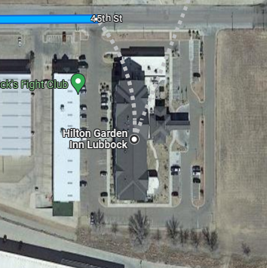
4. Stop 1: Phillips 66 - 225-Wheeler Ave., Texico, NM 88135 (1.27 hrs./90 miles into ride @approx 0845)
A. KSU: 0900
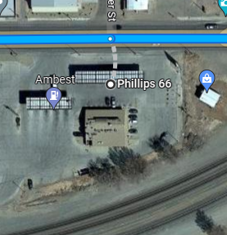
5. Stop 2: Valero – 101 US-54, Logan, NM 88426 (1.31 hrs/89.8 miles. Approx. 1030).
A. KSU: 1045
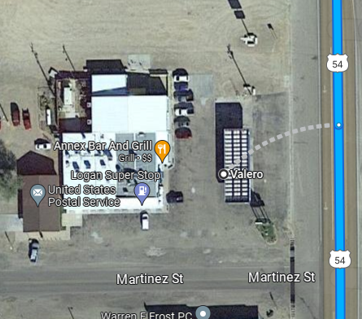
5. Stop 3 : Pendleton Station- 500 Richelieu St., Roy, NM 87743 (1.06 hrs./68.2. Approx 1150) *Note : This station is very small. 1 pump with two sides to it. Will take a little longer to fuel up but it should work. The next fuel location would be an excessively long stretch.
- KSU: 1215
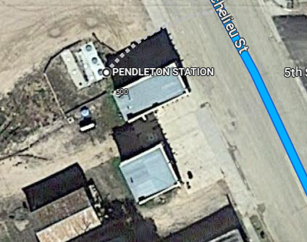
6. Stop 4: 87 Express – 901 Clayton Rd., Raton, NM 87740 (1.17 hrs., approx. 1335)
A. KSU: 1430
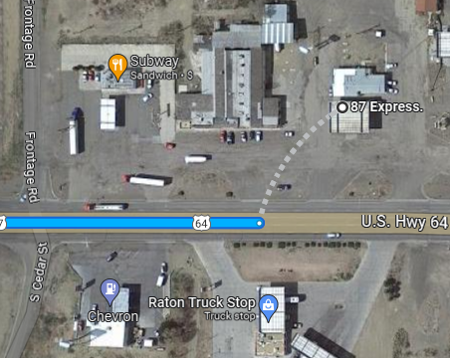

7. Stop 5: Exxon – 6654 CO-165, Colorado City, CO 81019 (1.15hrs./83.7 miles approx. 1545
A. KSU: 1500
8. Stop 6: Option 1: 235 Mesa Ave. Manitou Springs, Colorado (aka -Sausage Fest)(1.14hrs/73.9 miles Approx 1615)
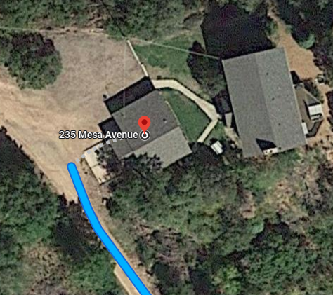
Option 2: 201 E. Kiowa, Colorado Springs, CO 80903 (Hotel (Hawk/Guardrail, Viking/Bootsie)(1.2hrs., 68.1 miles, Approx 1600)
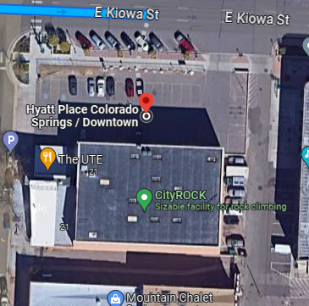

Turn by Turn Instructions

Hilton Garden Inn Lubbock
6027 45th St, Lubbock, TX 79407
Head west on 45th St toward Iola Ave
0.2 mi
Turn right onto Ironton Ave
0.2 mi
Turn left onto 43rd St
0.4 mi
Turn right onto Milwaukee Ave
7.0 mi
Turn left onto US-84 W

Entering New Mexico
Destination will be on the left
82.3 mi
1 hr 27 min (90.1 mi)

Phillips 66
225 Wheeler Ave, Texico, NM 88135
Head west on Wheeler Ave toward N Garwood St

Pass by Dollar General (on the left)
0.3 mi
Turn right onto State Rte 108/N College St/Curry Rd B

Continue to follow State Rte 108/Curry Rd B
5.2 mi
Turn left onto County Rd 14/C R 14
Continue to follow County Rd 14
8.0 mi
Turn right onto NM-209 N
31.1 mi
Turn right onto NM-469 N/Curry Rd Q

Continue to follow NM-469 N
43.4 mi
Turn right onto US-54 E

Pass by Subway (on the right in 1.7 mi)

Destination will be on the left
1.9 mi
1 hr 31 min (89.8 mi)

Valero
101 US-54, Logan, NM 88426
Head north on US-54 E toward Gallegos St
0.4 mi
Turn left onto NM-39 N

Destination will be on the left
67.8 mi
1 hr 6 min (68.2 mi)

PENDLETON STATION
500 Richelieu St, Roy, NM 87743
Head northwest on NM-39 N/Richelieu St toward Mesteno

Continue to follow NM-39 N
23 min (25.6 mi)

Follow US-412 W/US-56 W and I-25 N to US-64 E/US-87 S/Clayton Rd in Raton
54 min (58.6 mi)
1 hr 17 min (84.2 mi)

87 Express.
901 Clayton Rd, Raton, NM 87740
Head west on Clayton Rd toward Frontage Rd
0.1 mi
Turn right to merge onto I-25 N

Entering Colorado
83.3 mi
Take exit 74 for CO-165 W toward Colo City Rye
0.2 mi
Turn left onto CO-165 W
0.1 mi
Turn left

Destination will be on the left
151 ft
1 hr 15 min (83.7 mi)

Exxon
6654 CO-165, Colorado City, CO 81019

Get on I-25 N
1 min (0.4 mi)

Follow I-25 N to W Bijou St in Colorado Springs. Take exit 142 from I-25 N
58 min (67.2 mi)

Drive to W Kiowa St
2 min (0.5 mi)

1 hr 2 min (68.1 mi)

Hyatt Place Colorado Springs / Downtown
201 E Kiowa St, Colorado Springs, CO 80903
Or
235 Mesa Ave. Manitou Springs, CO 1 hr 15 min (83.7 mi)

*END CHAPTER RIDE
9. Weather Forecast for trip:
10. On-road communications:
A. RC/Viking’s cell: 202-203-9277, TG/Chief’s cell: 512-378-3680.
B. Life 360 App location tracking turned ON before leaving home until returned home.
14. GENERAL info: Please read and be familiar with the following, all riders are responsible to know riding SOP:
A. STAGGERED RIDING – minimum (that means the faster the further separation as speed requires) 2-second spacing behind rider directly in front of you and 1- second spacing behind the rider DIAGONALLY in front of you. This rule is not negotiable DO NOT ride side by side. ALWAYS ASSUME the rider in front of you will stop at a yellow light, DO NOT assume they will go through even if others do!
B. Stop signs when no blockers have been assigned –
1. If a small group (6 or less): RC will stop formation, once he signals to move, entire group will move together as if it were one vehicle.
2. If a large group (> 6): RC will likely assign road guards, if RC does not do so, approach stop sign in pairs and move on together when legally and safely permissible. The RC will slow or stop to allow those catching up to do so without speeding until the TG is visible and group is back together.
C. ROLLING BLOCKS – know the difference between RC blocking or #2/#3 rider when signaled and how to properly resume positions. (RC will brief at Link up).
D. LANE CHANGING – Upon RC signaling, all riders pass direction hand signal back, Tail Gunner moves first, followed by the RC, then main body moves in sequential order following RC.
E. SPLITTING LANES - for short/temporary passing areas: The RC will either move group to the right lane and slow to allow traffic to pass OR hold up the “rocker sign” (index and pinky fingers) and wave signal side to side above head. When this signal is commanded, it is passed back to TG. Immediately upon signaling, the right side of the formation occupies the right lane, the left side occupies the left lane preventing cars from attempting to pass the group, potentially separating the group, or causing an accident by forcing between us. Riders remain in both lanes until the lanes merge back to one lane reassuming the normal formation intervals.
E. BREAK DOWN/ACCIDENT – Formation will pull over to safest spot to assist, flashers on. RC/TG will:
1. Assign Road Guards and deploy (ID who has reflective vests and discuss procedures to direct traffic safely away from formation or incident scene).
2. Assign Medical personnel (if present) and ID location of Med bags).
3. Assign someone to call 911 or Tow vehicle (as required).

Note* All riders ensure they have inspected their motorcycle prior to trip and have at a minimum checked:
- Tire Pressure
- Headlights, taillights, and turn signals work.
- Oil levels
- Have license, registration and insurance card, tire, and extended warranty info as applicable.
- Toll Pass if applicable
- water in case of breakdown/emergency (can be stuck on side of the road for a while)
F. Formation Separation – If formation gets divided by a light or any other circumstance such as traffic, Lead RC will slow forward group to allow rear group to catch up or pull over at the next safe and visible location to wait for group. Separated group is to continue moving at legal speeds until caught up with the lead group.

