CVMA 23-7 Return Ride to Austin From Nationals 2023
6/10/2023 TBD LU – TBD+20 KSU
1. Road Captain: Caesar
2. Tail Gunner: Viking

Ride Plan Overview and Graphics

3. Day 1 Link-up (Start) location: DoubleTree by Hilton Hotel, 1775 East Cheyenne Mountain Blvd.
Colorado Springs, Colorado 80906

Notes:
- As the Aux Meeting is at the host hotel, we will meet up there as it is heading south.
- FMs will arrive as soon as possible and join up as soon as AMs are done.
- We will stop and fill up before getting on the road after LU.
- We will either eat before leaving Colorado Springs or find a place along the way depending on time.
- We will be losing an hour as going from MT to CT.

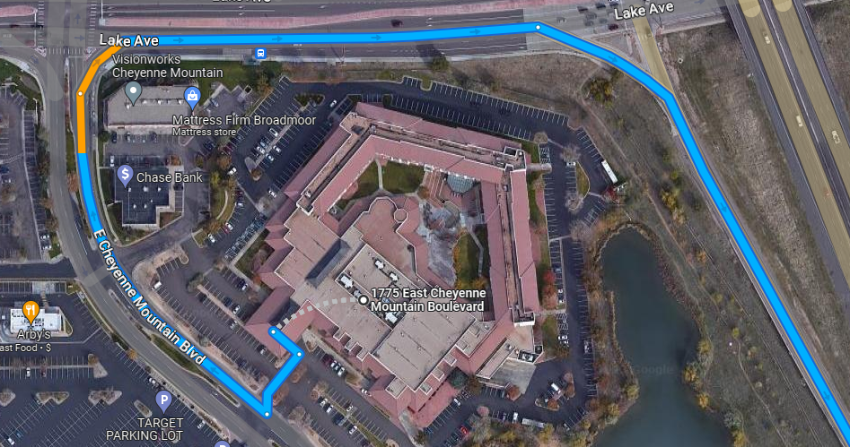
4. Gas Stop: Love’s Travel Stop, 99800 I-25, Walsenburg, CO 81089, TBD hrs, 10 min break, 90 miles

5. Gas Stop: Sinclair, 6 Sierra Grande Rd, Des Moines, NM 88418, TBD hrs, 30 min break, 98 miles

6. Gas Stop: Valero, 313 Peach Ave, Dalhart, TX 79022, TBD hrs, 15 min break, 90 miles

7. Destination: Hilton Garden Inn Amarillo, 9000 I-40, Amarillo, TX 79124, TBD hrs, 78 miles
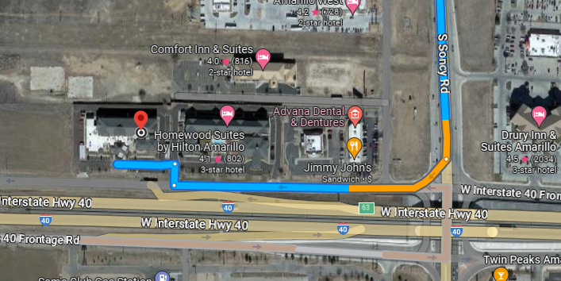

8. Day 2 Link-up (Start) location: Hilton Garden Inn Amarillo, 9000 I-40, Amarillo, TX 79124, 0700 LU – 0715 KSU
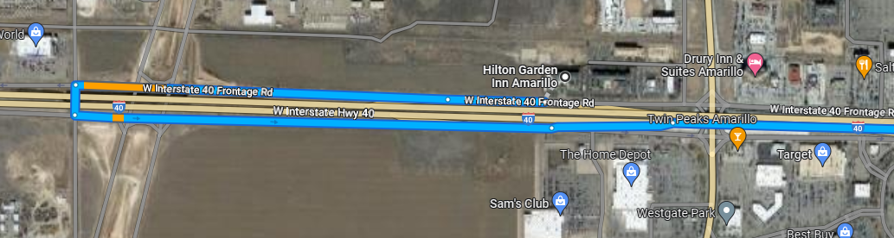
9. Gas Stop: Pilot, 2301 Ave F NW, Childress, TX 79201, 0915–0930 hrs, 15 min break, 121 miles

10. Gas Stop: Cooper Oil Co, 33 S Central Ave, Hamlin, TX 79520, 1130 – 1140 hrs, 10 min break, 112 miles

11. Lunch Stop: Camacho and Charlie’s Grill and Cantina, 311 S Central Ave, Hamlin, TX 79520, 1145-1245 hrs

12. Gas Stop: ALON, 241 SW Fifth St, Cross Plains, TX 76443, 1415 – 1430 hrs, 15 min break, 85 miles

13. Gas Stop: Sunoco, 801 N Key Ave, Lampasas, TX 76550, 1615 – 1630 hrs, 15 min break, 103 miles
Last Group Stop. Group rides together down 183 and will break up as needed to head home.

Turn by Turn Instructions

14. Day 1 Trip Totals: 353 miles, 5.5 hours of riding.

Start Point: DoubleTree by Hilton Hotel, 1775 East Cheyenne Mountain Blvd.

Colorado Springs, Colorado 80906

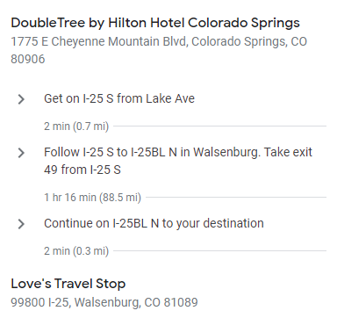

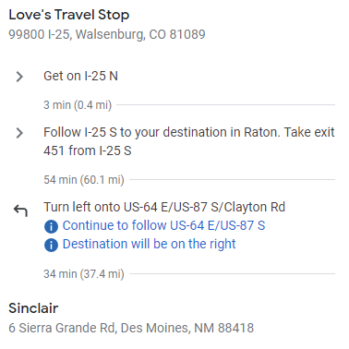

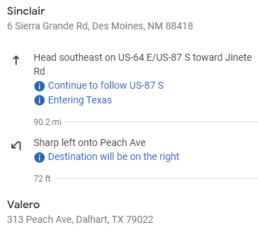

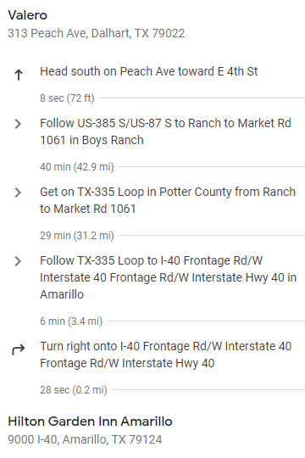

Turn by Turn Return Instructions
15. Day 2 Trip Totals: 422+ miles, 7+ hours of riding.

Start Point: Hilton Garden Inn Amarillo, 9000 I-40, Amarillo, TX 79124

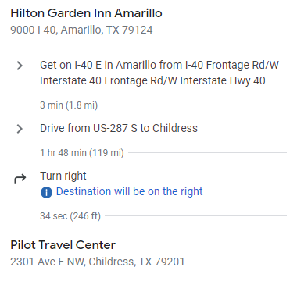

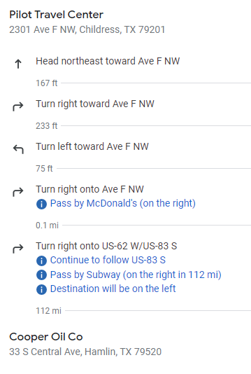

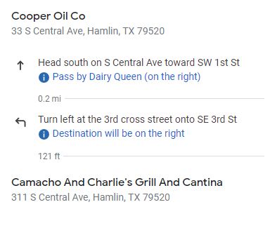

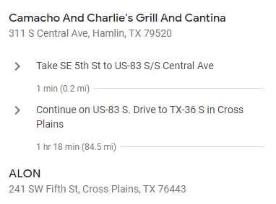

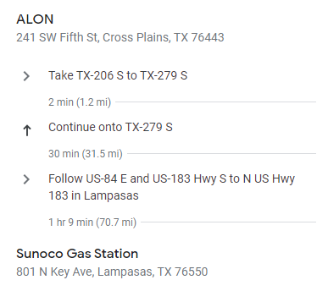

*END CHAPTER RIDE
15. On-road communications:
A. RC/Caesar’s cell: 512-496-9186, TG/Viking’s cell: 202-203-9277.
B. Life 360 App location tracking turned ON before leaving home until returned home.
16. GENERAL info: Please read and be familiar with the following, all riders are responsible to know riding SOP:
A. STAGGERED RIDING – minimum (that means the faster the further separation as speed requires) 2-second spacing behind rider directly in front of you and 1- second spacing behind the rider DIAGONALLY in front of you. This rule is not negotiable DO NOT ride side by side. ALWAYS ASSUME rider in front of you will stop at a yellow light, DO NOT assume they will go through even if others do!
B. Stop signs when no blockers have been assigned –
1. If small group (6 or less): RC will stop formation, once he signals to move, entire group will move together as if one vehicle.
2. If large group (> 6): RC will likely assign road guards, if RC does not do so, approach stop sign in pairs and move on together when legally and safely permissible. The RC will slow or stop to allow those catching up to do so without speeding until the TG is visible and group is back together
C. ROLLING BLOCKS – know the difference between RC blocking or #2/#3 rider when signaled and how to properly resume positions. (RC will brief at Link up).
D. LANE CHANGING – Upon RC signaling, all riders pass direction hand signal back, Tail Gunner moves first, followed by the RC, then main body moves in sequential order following RC.
E. SPLITTING LANES - for short/temporary passing areas: The RC will either move group to the right lane and slow to allow traffic to pass OR hold up the “rocker sign” (index and pinky fingers) and wave signal side to side above head. When this signal is commanded, it is passed back to TG. Immediately upon signaling, the right side of the formation occupies the right lane, the left side occupies the left lane preventing cars from attempting to pass the group, potentially separating the group, or causing an accident by forcing between us. Riders remain in both lanes until the lanes merge back to one lane reassuming the normal formation intervals.
E. BREAK DOWN/ACCIDENT – Formation will pull over to safest spot to assist, flashers on. RC/TG will:
1. Assign Road Guards and deploy (ID who has reflective vests and discuss procedures to direct traffic safely away from formation or incident scene).
2. Assign Medical personnel (if present) and ID location of Med bags).
3. Assign someone to call 911 or Tow vehicle (as required).

Note* All riders ensure they have inspected their motorcycle prior to trip and have at a minimum checked:
- Tire Pressure
- Head lights, taillights, turn signals work
- Oil levels
- Have license, registration and insurance card, tire and extended warranty info as applicable
- Toll Pass if applicable
- water in case of breakdown/emergency (can be stuck on side of the road for a while)
F. Formation Separation – If formation gets divided by a light or any other circumstance such as traffic, Lead RC will slow forward group to allow rear group to catch up or pull over at the next safe and visible location to wait for group. Separated group is to continue moving at legal speeds until caught up with the lead group.

