CVMA 23-7 Ride to Chapter 23-29 Meeting
13 AUG 2022/0800 LU – 0830 KSU
1. Road Captain: Bill “Viking” Zito
2. Tail Gunner: Bill “Chief” Langford

Ride Plan Overview and Graphics

3. Link-up (Start) location 0800, KSU 0830: Quick Trips Gas Station: 901 Louis Henna Blvd., Round Rock, TX
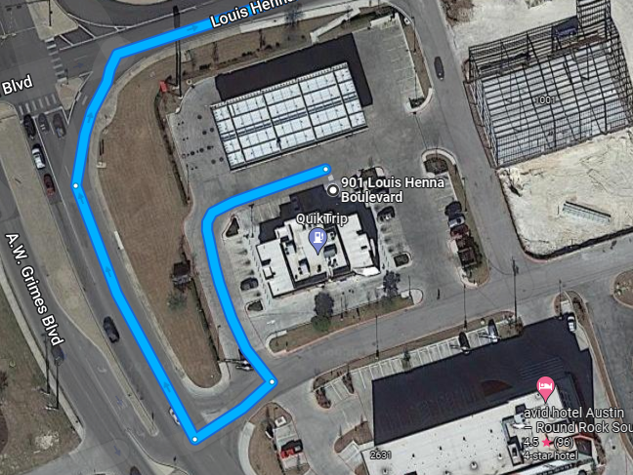
4. REST/FUEL Stop 1: Shell Gas Station – 1309 Prairie Lea St. Brenham, TX (1.30 hrs. into ride @approx 1000)
A. 15 min refuel/bathroom break
B. KSU: 1015
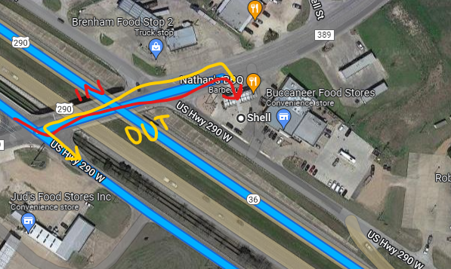
5. Destination: Back Pack Brewing – 26452 Sorters McClelland Rd., Porter, TX (1.16 hrs. from fuel stop @approx. 1130).
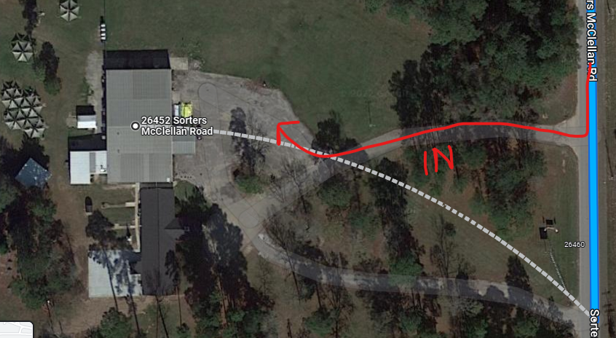
C. Social Time 1200-1230
D. Meeting 1230-1400
C. Link up 1415
D. KSU: 1430

5. REST/FUEL Stop : Malloy’s – 13200 U.S. 290, Burton, TX (1.30 hrs. from Brewery, arrival 1600)
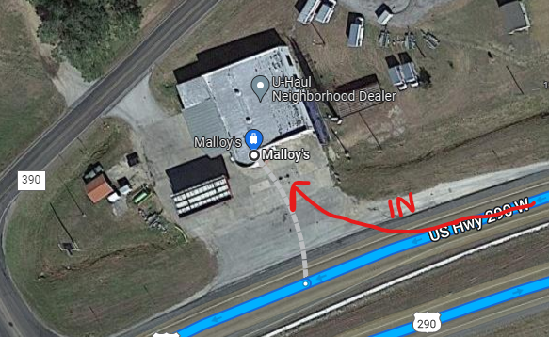
- 30 min fuel/bathroom/hydrate
- KSU: 1630
6. Final Stop/Release Point: (OPTIONAL): Shell Station – 1909 Kelly Ln., Plugerville, TX (1.16 hrs. from Malloy’s, @ 1745)
A. This stop is optional but added for those that have further north locations for home and may need fuel or a hydration break.
B. Fuel/Bathroom/Hydrate
*END OF RIDE PLAN
Turn by Turn Instructions
7. Trip Totals: 339 miles, 5.30 hours of riding – Start 0800, End 1745.
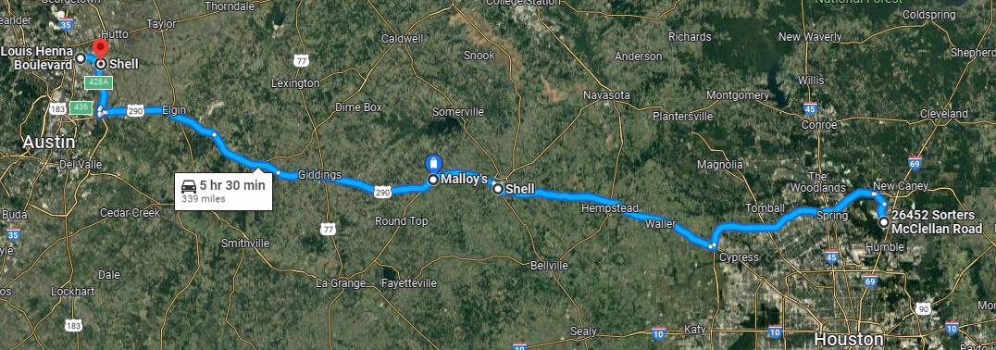

Start/Link Up: Quick Trip Gas Station - 901 Louis Henna Blvd (Start)
Round Rock, TX 78664

Depart - Get on TX-45 E/TX-45 Toll from Louis Henna Blvd
2 min (0.5 mi)

Follow TX-130 S/TX-130 Toll S and US-290 E to Feeder Rd/US Hwy 290 W in Brenham. Take the exit toward FM 389/Blinn College from US-290 E
1 hr 28 min (89.7 mi)

Continue on Feeder Rd/US Hwy 290 W. Drive to Prairie Lea St
49 s (0.2 mi)
1 hr 31 min (90.4 mi)

Stop 1: Shell
1309 Prairie Lea St, Brenham, TX 77833

Depart - Get on US-290 E
1 min (0.3 mi)

Follow US-290 E and TX-99/Grand Pkwy to FM1314 S in Porter. Take the FM 1314 exit from TX-99/Grand Pkwy
1 hr 5 min (74.9 mi)

Drive to Sorters Rd
10 min (6.0 mi)
1 hr 16 min (81.1 mi)

Stop 2: Back Pack Brewery - 26452 Sorters McClellan Rd
Porter, TX 77365

Depart - Get on State Rte 99/TX-99 in Porter
11 min (6.4 mi)

Follow State Rte 99/TX-99 to US-290 W/US Hwy 290 W in Brenham. Take the US-290 W exit from US-290 W
1 hr 6 min (76.2 mi)
Continue onto US-290 W/US Hwy 290 W

Destination will be on the right
10 min (11.2 mi)
1 hr 28 min (93.8 mi)

Stop 3: Malloy's (Fuel/Rest)
13200 US-290, Burton, TX 77835

Depart: Take US-290 W to TX-130 Service Rd in Pflugerville. Take exit 428A from TX-130 N/TX-45
1 hr 12 min (72.4 mi)

Continue on TX-130 Service Rd to your destination
4 min (1.0 mi)
1 hr 16 min (73.4 mi)

Stop 4: (OPTIONAL) Shell Gas/Rest
1909 Kelly Ln, Pflugerville, TX 78660
*END CHAPTER RIDE
8. On-road communications:
A. RC/Viking’s cell: 202-203-9277, TG/Chief’s cell: 512-378-3680.
B. Life 360 App location tracking turned ON before leaving home until returned home.
9. GENERAL info: Please read and be familiar with the following, all riders are responsible to know riding SOP:
A. STAGGERED RIDING – minimum (that means the faster the further separation as speed requires) 2-second spacing behind rider directly in front of you and 1- second spacing behind the rider DIAGONALLY in front of you. This rule is not negotiable DO NOT ride side by side. ALWAYS ASSUME rider in front of you will stop at a yellow light, DO NOT assume they will go through even if others do!
B. Stop signs when no blockers have been assigned –
1. If small group (6 or less): RC will stop formation, once he signals to move, entire group will move together as if one vehicle.
2. If large group (> 6): RC will likely assign road guards, if RC does not do so, approach stop sign in pairs and move on together when legally and safely permissible. The RC will slow or stop to allow those catching up to do so without speeding until the TG is visible and group is back together
C. ROLLING BLOCKS – know the difference between RC blocking or #2/#3 rider when signaled and how to properly resume positions. (RC will brief at Link up).
D. LANE CHANGING – Upon RC signaling, all riders pass direction hand signal back, Tail Gunner moves first, followed by the RC, then main body moves in sequential order following RC.
E. SPLITTING LANES - for short/temporary passing areas: The RC will either move group to the right lane and slow to allow traffic to pass OR hold up the “rocker sign” (index and pinky fingers) and wave signal side to side above head. When this signal is commanded, it is passed back to TG. Immediately upon signaling, the right side of the formation occupies the right lane, the left side occupies the left lane preventing cars from attempting to pass the group, potentially separating the group, or causing an accident by forcing between us. Riders remain in both lanes until the lanes merge back to one lane reassuming the normal formation intervals.
E. BREAK DOWN/ACCIDENT – Formation will pull over to safest spot to assist, flashers on. RC/TG will:
1. Assign Road Guards and deploy (ID who has reflective vests and discuss procedures to direct traffic safely away from formation or incident scene).
2. Assign Medical personnel (if present) and ID location of Med bags).
3. Assign someone to call 911 or Tow vehicle (as required).

Note* All riders ensure they have inspected their motorcycle prior to trip and have at a minimum checked:
- Tire Pressure
- Head lights, taillights, turn signals work
- Oil levels
- Have license, registration and insurance card, tire and extended warranty info as applicable
- Toll Pass if applicable
- water in case of breakdown/emergency (can be stuck on side of the road for a while)
F. Formation Separation – If formation gets divided by a light or any other circumstance such as traffic, Lead RC will slow forward group to allow rear group to catch up or pull over at the next safe and visible location to wait for group. Separated group is to continue moving at legal speeds until caught up with the lead group.

