CVMA 23-7 Ride to Burnet, TX
12/3/2022 0830 LU – 0840 KSU
1. Road Captain: Jabba
2. Tail Gunner: Chief

Ride Plan Overview and Graphics

3. Link-up (Start) location: HNO, 1150 S Bell Blvd, Cedar Park, TX 78613
Note* Everyone should top off with fuel before arriving at this LU point.
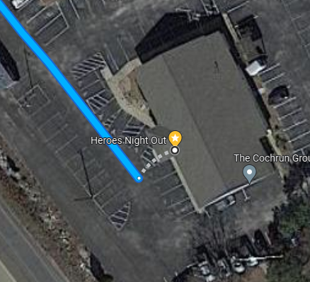

4. Destination: Hill Country Motorheads Motorcycle Museum, 2001 W State Hwy 29, Burnet, TX 78611
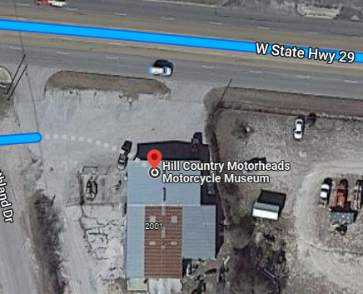
Google Maps Link: https://goo.gl/maps/hNKfePhgji9Ma49Q8
Turn by Turn Instructions
5. Trip Totals: 36.6 miles, 51 min of riding – Start 0840hrs., End approx. 0931hrs.

Start Point: HNO, 1150 S Bell Blvd, Cedar Park, TX 78613

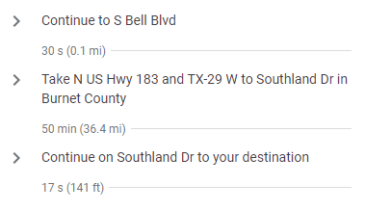

Hill Country Motorheads Motorcycle Museum, 2001 W State Hwy 29, Burnet, TX 78611

Return Trip: TX-29 E to US 183 Hwy. Break off to home.

*END CHAPTER RIDE
12. On-road communications:
A. RC/Jabba’s cell: 253-970-8270, TG/Chief’s cell: 512-378-3680.
B. Life 360 App location tracking turned ON before leaving home until returned home.
13. GENERAL info: Please read and be familiar with the following, all riders are responsible to know riding SOP:
A. STAGGERED RIDING – minimum (that means the faster the further separation as speed requires) 2-second spacing behind rider directly in front of you and 1- second spacing behind the rider DIAGONALLY in front of you. This rule is not negotiable DO NOT ride side by side. ALWAYS ASSUME rider in front of you will stop at a yellow light, DO NOT assume they will go through even if others do!
B. Stop signs when no blockers have been assigned –
1. If small group (6 or less): RC will stop formation, once he signals to move, entire group will move together as if one vehicle.
2. If large group (> 6): RC will likely assign road guards, if RC does not do so, approach stop sign in pairs and move on together when legally and safely permissible. The RC will slow or stop to allow those catching up to do so without speeding until the TG is visible and group is back together
C. ROLLING BLOCKS – know the difference between RC blocking or #2/#3 rider when signaled and how to properly resume positions. (RC will brief at Link up).
D. LANE CHANGING – Upon RC signaling, all riders pass direction hand signal back, Tail Gunner moves first, followed by the RC, then main body moves in sequential order following RC.
E. SPLITTING LANES - for short/temporary passing areas: The RC will either move group to the right lane and slow to allow traffic to pass OR hold up the “rocker sign” (index and pinky fingers) and wave signal side to side above head. When this signal is commanded, it is passed back to TG. Immediately upon signaling, the right side of the formation occupies the right lane, the left side occupies the left lane preventing cars from attempting to pass the group, potentially separating the group, or causing an accident by forcing between us. Riders remain in both lanes until the lanes merge back to one lane reassuming the normal formation intervals.
E. BREAK DOWN/ACCIDENT – Formation will pull over to safest spot to assist, flashers on. RC/TG will:
1. Assign Road Guards and deploy (ID who has reflective vests and discuss procedures to direct traffic safely away from formation or incident scene).
2. Assign Medical personnel (if present) and ID location of Med bags).
3. Assign someone to call 911 or Tow vehicle (as required).

Note* All riders ensure they have inspected their motorcycle prior to trip and have at a minimum checked:
- Tire Pressure
- Head lights, taillights, turn signals work
- Oil levels
- Have license, registration and insurance card, tire and extended warranty info as applicable
- Toll Pass if applicable
- water in case of breakdown/emergency (can be stuck on side of the road for a while)
F. Formation Separation – If formation gets divided by a light or any other circumstance such as traffic, Lead RC will slow forward group to allow rear group to catch up or pull over at the next safe and visible location to wait for group. Separated group is to continue moving at legal speeds until caught up with the lead group.

